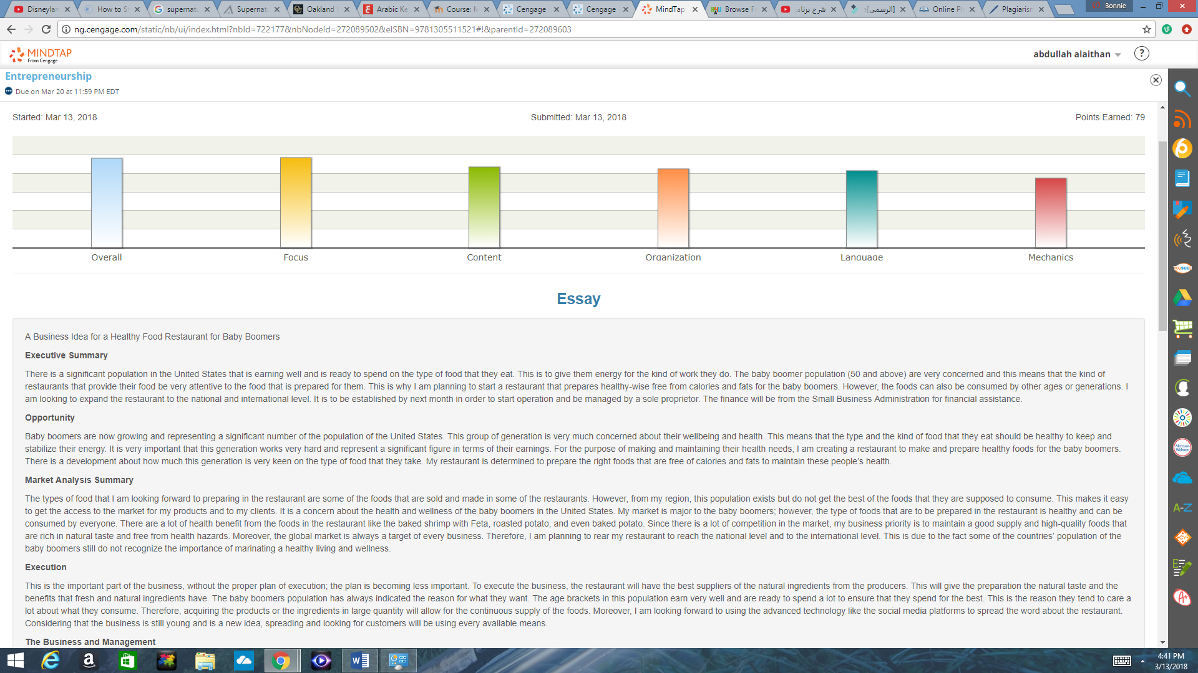

Focuse

Revision Goal 1: Understand what you did you well so that you can consistently do well.
1. You established and maintained a clear controlling idea or bottom line.
2. You demonstrated an understanding of the purpose of the assignment.
3. You adapted your message to the audience.
Revision Goal 2: Understand what you could have done better.
1. Your controlling idea or bottom line could have been insightful as well as clear.
2. Your understanding of the purpose could have been more thorough.
3. You could have more clearly adapted your message to the audience.
Consider this paragraph:
"We at XYZ Company know how difficult it is to quit smoking, despite the health benefits of doing so. As we evaluate the smoking policy and health care coverage in regard to smoking cessation programs, we will consider the rights and responsibilities of all employees."
Now examine the revision:
"The management team at XYZ Company acknowledges how difficult it is to quit smoking, despite the health benefits of doing so. As we evaluate the smoking policy and health care coverage in regard to smoking cessation programs, we will consider the rights and responsibilities of all employees -- those who smoke, those who are trying to quit, and those who do not smoke."
The first paragraph is good, but the second one is stronger in two ways:
1. It identifies the management team up front and changes the verb "know" to "acknowledges" for the sake of consistency. This helps the audience, the employees, understand that the document comes from the highest levels.
2. It adds a parallel phrase at the end ("those who smoke...") that emphasizes the idea that the employees are a team, not just individuals. This parallelism also helps reinforce the purpose of the document: the idea that the changes to the company's health plan will be made with care toward their concerns.
As the above example shows, it is always possible to improve your work.
Revision Goal 1: Follow these steps to improve your use of mechanics and conventions.
Use the MY Editor feedback to improve your understanding of mechanics and conventions.
1. Pay attention to the specific feedback that MY Editor gives you as you compose and edit your document. Begin by revising any spelling or punctuation errors you have committed. Then run MY Editor again to reexamine any remaining grammar errors that remain.
2. Write down the terms used in the feedback.
3. Study the terms that came up most often.
4. When you master your understanding of a particular term, move on to a new one.
Network to improve your understanding of mechanics and conventions.
1. Start or join a small, serious study group on the topic of mechanics and conventions.
2. Ask your instructor to recommend other resources to help you master mechanics and conventions.
When you rewrite your document, pay attention to your sentences to avoid errors in mechanics and conventions.
1. Place a period at the end of each of your complete thoughts/sentences.
2. Place the subjects of your sentences as close as you can to the beginning of your sentences.
When you rewrite your document, focus on correcting the errors that came up the most often in the original document.

Contect
Revision Goal 1: Offer support for developing a concept or idea.
1. Read your document. Highlight one or two specific concepts or ideas that can be more sufficiently developed.
Example: Paola finds a sentence in her document that could be further developed: "The different communication styles of committee members can affect whose ideas are heard."
2. Add details such as explanations, facts, or arguments that can support each idea.
Example: Paola realizes that the communication styles of committee members is an area that could use further development. She chooses to focus on the role of the committee chair in smoothing out the differences between committee members who have different communication styles.
3. Now incorporate those supporting ideas into your document.
Example: Paola uses transitional expressions to help incorporate her supporting details into her document: "Successful committee chairs should observe the different communication styles of the committee members and adjust how they conduct meetings accordingly. For instance, if the other members of a committee are constantly talking over a member who speaks more slowly than others, the chair should step in and directly ask that member for his or her contribution."
Revision Goal 2: Show the use and understanding of business concepts and terms.
1. Read through your document and highlight at least two areas where you can include relevant business concepts or terms.
Example: One of the areas that Patrick finds is this sentence: "To run a restaurant, the owner should pay attention to how much stuff costs."
2. Create a list of three business concepts or business terms that could be included in your document in these areas.
Example: Patrick creates a list of business terms that fit this subject:
"Budget."
"Labor.
"Capital equipment."
3. Now incorporate these business concepts or terms into your document.
Example: Patrick incorporates the terms into his sentence: "To maintain an accurate budget, a restaurant owner should be aware of the costs of labor and capital equipment."
Revision Goal 1: Follow these steps to improve your use of mechanics and conventions.
Use the MY Editor feedback to improve your understanding of mechanics and conventions.
1. Pay attention to the specific feedback that MY Editor gives you as you compose and edit your document. Begin by revising any spelling or punctuation errors you have committed. Then run MY Editor again to reexamine any remaining grammar errors that remain.
2. Write down the terms used in the feedback.
3. Study the terms that came up most often.
4. When you master your understanding of a particular term, move on to a new one.
Network to improve your understanding of mechanics and conventions.
1. Start or join a small, serious study group on the topic of mechanics and conventions.
2. Ask your instructor to recommend other resources to help you master mechanics and conventions.
When you rewrite your document, pay attention to your sentences to avoid errors in mechanics and conventions.
1. Place a period at the end of each of your complete thoughts/sentences.
2. Place the subjects of your sentences as close as you can to the beginning of your sentences.
When you rewrite your document, focus on correcting the errors that came up the most often in the original document.

Organization
Revision Goal 1: Establish and maintain a controlling idea or bottom line throughout the document.
1. Re-read your document. Highlight sentences that could serve as the controlling idea or bottom line.
Example: Maria's document is organized well enough, so she quickly finds the sentence she wants to use as a controlling idea: "Learning to program the free and open source operating system (FOSS) has improved my studies, my job prospects, and my self-esteem."
2. Now that you have the controlling idea or bottom line of your document, make sure that the support for it forms the basis of the paragraphs in your document.
Example: Maria controlling idea can form the basis for three paragraphs. One would focus on how learning to program the FOSS improved her studies; the second would focus on how learning to program the FOSS improved her job prospects; the third would focus on how learning to program the FOSS improved her self-esteem.
3. For each paragraph, make sure you have at least three supporting details.
Example: Maria decides to start with how learning to program the FOSS improved her studies. Learning how to program the FOSS taught her to approach problems logically, to develop critical thinking skills, and to think more precisely.
4. Integrate key words from your controlling idea into your supporting details. In addition, use transitional expressions to connect your thoughts.
Example: Maria now has to take the ideas she brainstormed and turn them into a paragraph that will fit into her document. This is what she writes: "Learning how to program the FOSS taught me several skills that improved my grades. It taught me to approach problems logically, step-by-step. That approach especially improved my grades in algebra. It further developed my critical thinking skills, how to view problems in a program as puzzles to be solved. That approach also helped me in biology. In addition, it taught me to think more precisely, since even tiny errors in programs can result in wasted time. That precision has helped me in all of my classes."
Revision Goal 1: Follow these steps to improve your use of mechanics and conventions.
Use the MY Editor feedback to improve your understanding of mechanics and conventions.
1. Pay attention to the specific feedback that MY Editor gives you as you compose and edit your document. Begin by revising any spelling or punctuation errors you have committed. Then run MY Editor again to reexamine any remaining grammar errors that remain.
2. Write down the terms used in the feedback.
3. Study the terms that came up most often.
4. When you master your understanding of a particular term, move on to a new one.
Network to improve your understanding of mechanics and conventions.
1. Start or join a small, serious study group on the topic of mechanics and conventions.
2. Ask your instructor to recommend other resources to help you master mechanics and conventions.
When you rewrite your document, pay attention to your sentences to avoid errors in mechanics and conventions.
1. Place a period at the end of each of your complete thoughts/sentences.
2. Place the subjects of your sentences as close as you can to the beginning of your sentences.
When you rewrite your document, focus on correcting the errors that came up the most often in the original document.

Mechanics
Revision Goal 1: Establish and maintain a controlling idea or bottom line throughout the document.
1. Re-read your document. Highlight sentences that could serve as the controlling idea or bottom line.
Example: Maria's document is organized well enough, so she quickly finds the sentence she wants to use as a controlling idea: "Learning to program the free and open source operating system (FOSS) has improved my studies, my job prospects, and my self-esteem."
2. Now that you have the controlling idea or bottom line of your document, make sure that the support for it forms the basis of the paragraphs in your document.
Example: Maria controlling idea can form the basis for three paragraphs. One would focus on how learning to program the FOSS improved her studies; the second would focus on how learning to program the FOSS improved her job prospects; the third would focus on how learning to program the FOSS improved her self-esteem.
3. For each paragraph, make sure you have at least three supporting details.
Example: Maria decides to start with how learning to program the FOSS improved her studies. Learning how to program the FOSS taught her to approach problems logically, to develop critical thinking skills, and to think more precisely.
4. Integrate key words from your controlling idea into your supporting details. In addition, use transitional expressions to connect your thoughts.
Example: Maria now has to take the ideas she brainstormed and turn them into a paragraph that will fit into her document. This is what she writes: "Learning how to program the FOSS taught me several skills that improved my grades. It taught me to approach problems logically, step-by-step. That approach especially improved my grades in algebra. It further developed my critical thinking skills, how to view problems in a program as puzzles to be solved. That approach also helped me in biology. In addition, it taught me to think more precisely, since even tiny errors in programs can result in wasted time. That precision has helped me in all of my classes."
Revision Goal 1: Follow these steps to improve your use of mechanics and conventions.
Use the MY Editor feedback to improve your understanding of mechanics and conventions.
1. Pay attention to the specific feedback that MY Editor gives you as you compose and edit your document. Begin by revising any spelling or punctuation errors you have committed. Then run MY Editor again to reexamine any remaining grammar errors that remain.
2. Write down the terms used in the feedback.
3. Study the terms that came up most often.
4. When you master your understanding of a particular term, move on to a new one.
Network to improve your understanding of mechanics and conventions.
1. Start or join a small, serious study group on the topic of mechanics and conventions.
2. Ask your instructor to recommend other resources to help you master mechanics and conventions.
When you rewrite your document, pay attention to your sentences to avoid errors in mechanics and conventions.
1. Place a period at the end of each of your complete thoughts/sentences.
2. Place the subjects of your sentences as close as you can to the beginning of your sentences.
When you rewrite your document, focus on correcting the errors that came up the most often in the original document.

